APQB Unit 4.6 Monetary Policy Tools 1
- Which of the following will happen if the central bank of a nation purchases government bonds on the open market?
- The monetary base will increase and the money supply will increase.
- The monetary base will increase and the money supply will not change.
- The monetary base will decrease and the money supply will increase.
- The monetary base will decrease and the money supply will not change.
- The monetary base will decrease and the money supply will decrease.
- The diagram shows the effect of a monetary policy action on aggregate demand.
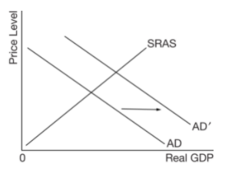
Which of the following will shift the aggregate demand curve in the direction shown in the diagram above?
- A decrease in the money supply
- A decrease in the monetary base
- A decrease in the discount rate
- An increase in the required reserve ratio
- The sale of bonds to the private sector by the central bank
- Which of the following is a monetary policy action a central bank would implement to control inflation?
- Increase income tax rates
- Sell government bonds to the public
- Lower the discount rate
- Lower the required reserve ratio
- Increase the monetary base
- Which of the following accurately describes the discount rate?
- The interest rate that banks charge state governments
- The interest rate that the Federal Reserve charges commercial banks for loans
- The interest rate that banks pay on long-term savings
- The interest rate on personal loans
- The interest rate on government bonds
- If aggregate demand is growing faster than long-run aggregate supply, the Federal Reserve is most likely to
- sell securities on the open market
- increase bond prices
- increase income taxes
- decrease the discount rate
- decrease the required reserve ratio
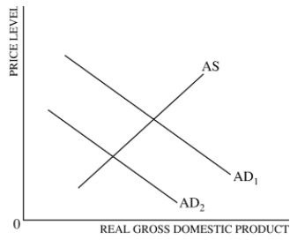
- The graph above shows two aggregate demand curves, AD1 and AD2, and an aggregate supply curve, AS. The shift in the aggregate demand curve from AD1 to AD2 could be caused by
- a decrease in taxes
- a decrease in the money supply
- an increase in government spending
- an increase in consumption spending
- an increase in the price level
- If the interest rate on short-term government bonds declined as a result of open market operations by a central bank, the central bank must have
- purchased government bonds
- sold government bonds to commercial banks
- decreased the amount of currency in circulation
- increased the supply of bonds
- increased the discount rate on loans to commercial banks
- An open-market operation by a country’s central bank to reduce the unemployment rate would be to
- sell bonds to decrease the interest rate and to increase aggregate demand
- sell bonds to increase the interest rate and to decrease aggregate demand
- sell bonds to increase the interest rate and to increase investment
- buy bonds to decrease the interest rate and to decrease aggregate demand
- buy bonds to decrease the interest rate and to increase aggregate demand
- Challenge Question: The purchase of bonds by the Federal Reserve will have the greatest effect on real gross domestic product if which of the following situations exists in the economy?
- The required reserve ratio is high, and the interest rate has a large effect on investment spending.
- The required reserve ratio is high, and the interest rate has a small effect on investment spending.
- The required reserve ratio is low, and the interest rate has a large effect on investment spending.
- The required reserve ratio is low, and the marginal propensity to consume is low.
- The marginal propensity to consume is high, and the interest rate has a small effect on investment spending.
- Which of the following is a monetary policy that can be used to counteract a recession?
- Buying bonds in the open market
- Increasing the discount rate
- Increasing the required reserve ratio
- Lowering tax rates
- Increasing government spending
- Assume that the reserve requirement for demand deposits is 20 percent, that banks hold no excess reserves, and that the public holds no currency. If the central bank sells $10,000 worth of government securities to commercial banks, the total money supply will
- increase by $10,000
- increase by $50,000
- decrease by $10,000
- decrease by $50,000
- not change
- If an economy is operating with significant unemployment, an increase in which of the following will most likely cause employment to increase and the interest rate to decrease?
- Purchases of government bonds by the central bank
- Transfer payments
- Reserve requirements
- Government expenditures
- Investment in basic infrastructure
- The Bank of Uchenna has the following balance sheet.
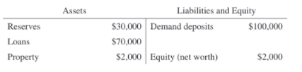
1 | A | 6 | B | 11 | D
2 | C | 7 | A | 12 | A
3 | B | 8 | E | 13
4 | B | 9 | C | 14
5 | A | 10 | A | 15

Assume that the reserve requirement ratio is 20 percent.
- Calculate the dollar value of the reserves that the Bank of Uchenna is required to hold.
- Given the current reserves, calculate the maximum value of additional loans that the Bank of Uchenna can make.
- Assume that Elike raises $5,000 in cash from a yard sale and deposits the cash in his checking account at the Bank of Uchenna. By how much does the money supply immediately change as a result of Elike’s deposit?
- Calculate the maximum change in demand deposits in the banking system as a whole resulting from Elike’s deposit.
- If the Bank of Uchenna is not meeting its reserve requirement, what action can it take to meet the reserve requirement without calling in loans or selling property?

- Assume that a country’s economy is in a short-run equilibrium and the actual unemployment rate is lower than the natural rate of unemployment.

- Using a correctly labeled graph of the long-run aggregate supply curve, short-run aggregate supply curve, and aggregate demand curve, show each of the following.
- Current price level, labeled PL1, and current output level, labeled Y1
- The full-employment output level, labeled YF.
- What open-market operation can the country’s central bank use to move the economy toward its long-run equilibrium?
- Use a correctly labeled money-market graph to show how the country’s central bank action to move the economy toward its long-run equilibrium affects the equilibrium nominal interest rate in the short run.
- Based on the interest rate change from part (c), will each of the following increase, decrease, or remain the same in the short run?
- Real output. Explain.
- Natural rate of unemployment
- Assume instead that the central bank does not pursue the monetary policy action from part (b) and there was no other government intervention. Will each of the following increase, decrease, or remain the same in the long run?
- Short-run aggregate supply. Explain.
- Employment

- Include correctly labeled diagrams, if useful or required, in explaining your answers. A correctly labeled diagram must have all axes and curves clearly labeled and must show directional changes. If the question prompts you to “Calculate,” you must show how you arrived at your final answer.
Assume Country X’s economy is currently at full employment.
(a) If country X’s net exports decrease, what will happen to the price level in Country X? Explain.
(b) Draw a correctly labeled graph of the money market, and show the effect of the change in the price level identified in part (a) on the nominal interest rate.
(c) Based on your answer to part (b), what will happen to the price of previously issued bonds?
(d) Identify an open market operation that country X’s central bank can use to offset the change in the nominal interest rate from part (b).

Answers

13
A - One point is earned for calculating the required reserves: $20,000.
B - One point is earned for calculating the maximum amount of additional loans that Bank of Uchenna can make as $10,000 (=$30,000 - $20,000).
C - One point is earned for stating that there will be no change in the money supply.
D - One point is earned for stating that the maximum change in demand deposits in the banking system is $25,000 (= $5,000 x 5).
E - One point is earned for stating that Bank of Uchenna can borrow from other banks to meet its reserve requirements or borrow from the central bank.

14
a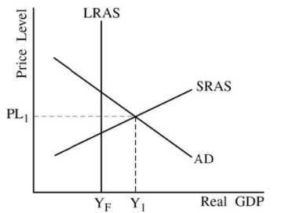

B - 1 point is earned for: stating that the central bank can sell bonds.
c

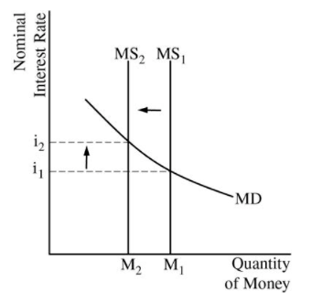
D - 1 point is earned for: stating that real output will decrease and for explaining that interest-sensitive spending will decrease, resulting in a decrease in aggregate demand and real output.
1 point is earned for: stating that the natural rate of unemployment will remain unchanged.
E - 1 point is earned for: stating that the short-run aggregate supply (SRAS) curve will shift to the left in the long run and for explaining that nominal wages will increase.
1 point is earned for: stating that employment will decrease.

15
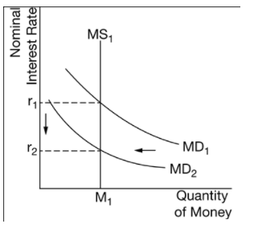
A - The response states that the price level will decrease and explains that the decrease in net exports shifts the aggregate demand curve to the left, which decreases both real output and the price level.
B
c - The response states that the price of previously issued bonds will increase.
D - The response states that the central bank should sell bonds.

